Formalization and analysis of a Resource Allocation Security Protocol for Secure Service Migration

Gayathri Karthick
School of Science and Technology
Middlesex University
London, United Kingdom
gk419@live.mdx.ac.uk

Dr.Mahdi Aiash
School of Science and Technology
Middlesex University
London, United Kingdom
M.Aiash@mdx.ac.uk
Dr.Glenford Mapp
School of Science and Technology
Middlesex University
London, United Kingdom
G.Mapp@mdx.ac.uk
(Happy to Swap)
Dr. Florian Kammueller
School of Science and Technology
Middlesex University
London, United Kingdom
F.kammueller@mdx.ac.uk

Abstract--The advent of virtual machine technology for example, VMware, and container technology, such as Docker, have made the migration of services between different Cloud Systems possible. This enables the development of mobile services that can ensure low latencies between servers and their mobile clients resulting in better QOS. Though there are many mechanisms in place to support for mobile services, a key component that is missing is the development of security protocols that allow the safe transfer of servers to different Cloud environments.
In this paper, we propose a Resource Allocation Security Protocol for secure service migration. We explore two approaches; In the first approach, the protocol is developed and formally verified by Automated Validation of Internet Security Protocols and Applications tool. The protocol satisfies security properties of secrecy and authentication. In addition, nonce are used for replay protection and to ensure freshness. In the second approach, a secure symmetrical session key is used to do the safe transfer and an automatic cryptographic protocol verifier ProVerif is employed to verify secrecy, authentication and key exchange.
Keywords— Mobile services, Security protocol, Vehicular Cloud, Avispa and ProVerif.

Introduction
Cloud computing facilitates the migration of data and services. This gives many benefits to data owners to migrate their data and services to Cloud storage platforms with low investments. In this brave new world, Cloud Providers will actively advertise their Cloud resources to Mobile Service Providers which can use these advertisements to dynamically migrate their servers to these Clouds. In this new environment, mobile users will demand to be always connected using heterogeneous networking. Mobile devices will, therefore, have several wireless interfaces including Wi-Fi, LTE, 5G, satellite and Ultra-wideband interfaces. These networks will seamlessly work together using vertical handover techniques. The Y-Comm architecture [1] has been developed to build future mobile systems that can provide seamless communications. Hence, future mobile systems will need to support both mobile users and services. Though extensive work has been done to support mobile users, less work has been done on the development of mobile services. However, there is now increasing interest in this area as there is a need to provide services at the edge of the network, i.e. to support edge-computing.
One aspect of the research on mobile services that has been inadequate is support for security [7]. In particular, it is important that servers do not end up being hosted on unsafe Cloud infrastructure which can hamper service delivery to mobile clients and also Clouds do not end up hosting malicious servers which can damage Cloud infrastructure. This paper attempts to address these issues by providing a new security protocol for secure service migration. This security protocol is named as Resource Allocation Security Protocol (RASP) for secure service migration over the Cloud.
The protocol is developed and tested through a simulation study using the Automated Validation of Internet Security Protocols and Applications (AVISPA) which is used for the analysis of large-scale Internet security sensitive protocols and applications. In the second approach, the ProVerif tool which verifies cryptographic protocols and associated security goals is employed. Using both techniques, this paper shows that the RASP protocol can be used to securely migrate services to different Cloud environments.
The rest of the paper is organized as follows. Section II presents the related work; Section III details the solution approach while Sections IV and V describe our first & second attempts of RASP, evaluation and shows the results. Section VI details of Applications to Vehicular Testbed. The paper concludes with Section VII.

Related work
Service migration has been proposed for many environments and is increasingly being used in Cloud infrastructure. Y-Comm is an architecture that has been designed to build heterogeneous mobile networks. It offers the most functionality and flexibility in terms of communications, mobility, QoS and security. Recently, a new Service-Oriented Architecture [2] that allows services to be managed, copied or migrated to support mobile users has been proposed. This framework takes into account recent efforts in the area of seamless connectivity across heterogeneous networks, as well as increasing capabilities of Cloud technology. Edge computing [9] has been growing rapidly to reduce the delays where servers are placed on Clouds close to the edge rather than at the centre of the Internet. Edge computing also enables support for networks that provide highly mobile environments such as Vehicular Ad-Hoc Networks (VANETs) [3]. Though all these mechanisms are promising developments, it is necessary to consider security as part of the overall design.

Solution Approach
In this section, we look at protocols for secure service migration. As stated previously, the main issues are fraudulent Cloud providers that entice service providers to host their services on faulty Cloud facilities resulting in data loss and lack of service as well as misbehaving services which convince Cloud providers that they are well-behaved systems leading to mismanagement and abuse of Cloud facilities. In our new approach, first discussed in [4], we are working on secure service migration between commercial Cloud infrastructures. This RASP protocol is to support for mobile services that allows the safe transfers of resources to different Cloud environments. This Protocol is broken into four stages to clarify the necessary operations involved in secure migration.
Stage1:  Advertisement | Cloud CB actively advertise its resources which is picked up by server SA on Cloud CA.
Stage2:  Authentication of SA and CB as well as migration request and response. | Server SA first requests the Registry to authenticate Cloud CB and the resources it holds. Once it receives the approval from the Registry, it sends a migration request to Cloud CB. Cloud CB requests the Registry to authenticate server SA and the resources it requires. Once this is verified, Cloud CB sends a positive migration response to server SA.
Stage3:  Migration transfer | Server SA sends a message to begin the migration transfer. The Cloud CB begins the transfer and signals server SA when the transfer is completed.
Stage4: Update of New service location to the Registry. | The new service SB is now running on Cloud CB and informs the Registry that it has been successfully migrated.
Table 1: Resources allocation Framework for four stages

First attempt
In RASP protocol, the services are moving from server SA on Cloud CA to Cloud CB. There are three entities in the protocol such as server SA on Cloud CA, Cloud CB, and Registry®.

General Notations:
- Server resources:
Server on Cloud A(SA) = Server_ID, TOS=Server, PKS, Resources required.
- Cloud facilities:
The Cloud facilities are represented as follows:
- Cloud A (CA) = Cloud_IDA, TOS = Cloud, PKA, Resources.
- Cloud B (CB) = Cloud_IDB, TOS = Cloud, PKB, Resources.
Each Cloud is uniquely identified by a Cloud_ID and since they are Cloud services, TOS = Cloud; PKA and PKB are public keys for Cloud CA and Cloud CB respectively. In addition, each Cloud will have a number of resources which it actively advertises to servers.
- The Registry®.
The Registry is the last key component and is used to verify the identities of all servers on the network. In addition, the Registry knows the services on different Clouds and has the public keys for each service. We represent the public key for the registry as PKR.
- Nonces and Timestamps:
Nonces (NA and NB) are randomly generated numbers which are unforgeable and are used as session tokens, ensuring that requests cannot be repaid by unauthorized personnel. Timestamps TA, TB & Tcomp are used to measure the time taken for the process. TA is the time when server makes the migration request to Cloud CB. TB is when the Cloud responds to the server request. Tcomp is the time when the transfer complete.

Algorithm 1 Resource Allocation Security Protocol for Migration between Server on Cloud A to Cloud B
This is our first attempt to implement the framework into the protocol. In this section, we look at when the service moves from Cloud CA to Cloud CB. In this attempt, Stage 1 in the previous Table 1, corresponds to step1 of the protocol; Stage 2 corresponds to steps 2-7; Stage 3 corresponds to steps 8 and 9 and finally the Stage 4 corresponds to step 10. The protocol is followed in exactly the same way as outlined below and Fig. 1 shows the steps for Cloud to Cloud migration of services.
- Stage 1:
- CB → SA : Advertisement (Cloud_IDB, TOS, Resources, PKB)
- Stage 2:
- SA → R : Verify_Identity (Cloud_IDB, TOS, PKB, Resources, Server_ID, PKS) PKR
- R → SA : Message: YES (Cloud_IDB, TOS, PKB, Valid Resources) PKS
- SA → CB : Migration_Request (Server_ID, TOS, TA, Req_Resources, PKS, NA) PKB
- CB → R : Verify_Identity (Server_ID, PKS, TOS, Cloud_IDB, PKB) PKR
- R → CB : Message: Yes (Server_ID, TOS, Valid Req_Resources(services)) PKB
- CB → SA : Migration_Response (Cloud_IDB, TOS= Cloud, TB, Resources_Granted, NA, NB) PKS
- Stage 3:
- SA → CB : Transfer_Migration (Server_ID, Cloud_IDB, Req_Resources, NB) PKB
- CB → SA : Transfer_Ack (Server_ID, Cloud_IDB, Tcomp) PKS
- Stage 4:
- SB → R : Transfer-Comp (Server_ID, Cloud_IDB, TOS, TA, TB, Tcomp) PKR.

The full explanation of this migration is given below:
- Step 1: The Server SA on Cloud A receives advertisements from Cloud B advertising its resources.
- Step 2: Server SA checks the validity of Cloud B.
- Step 3: The Registry authenticates Cloud B.
- Step 4: Server SA sends a request to migrate to Cloud B.
- Step 5: Cloud B sends a request to the Registry, make sure that the server SA, is a valid requested service.
- Step 6: The Registry validates server SA.
- Step 7: Cloud B signals to server SA that it is OK to migrate the requested service to Cloud B.
- Step 8: Server SA signals to Cloud B to migrate the service.
- Step 9: Cloud B signals to the server SA that the migration is complete: The service is now started on Cloud B. Hence, new location: (SA→SB)
- Step 10: The new server (SB) on Cloud B signals to the Registry that the migration has been completed.

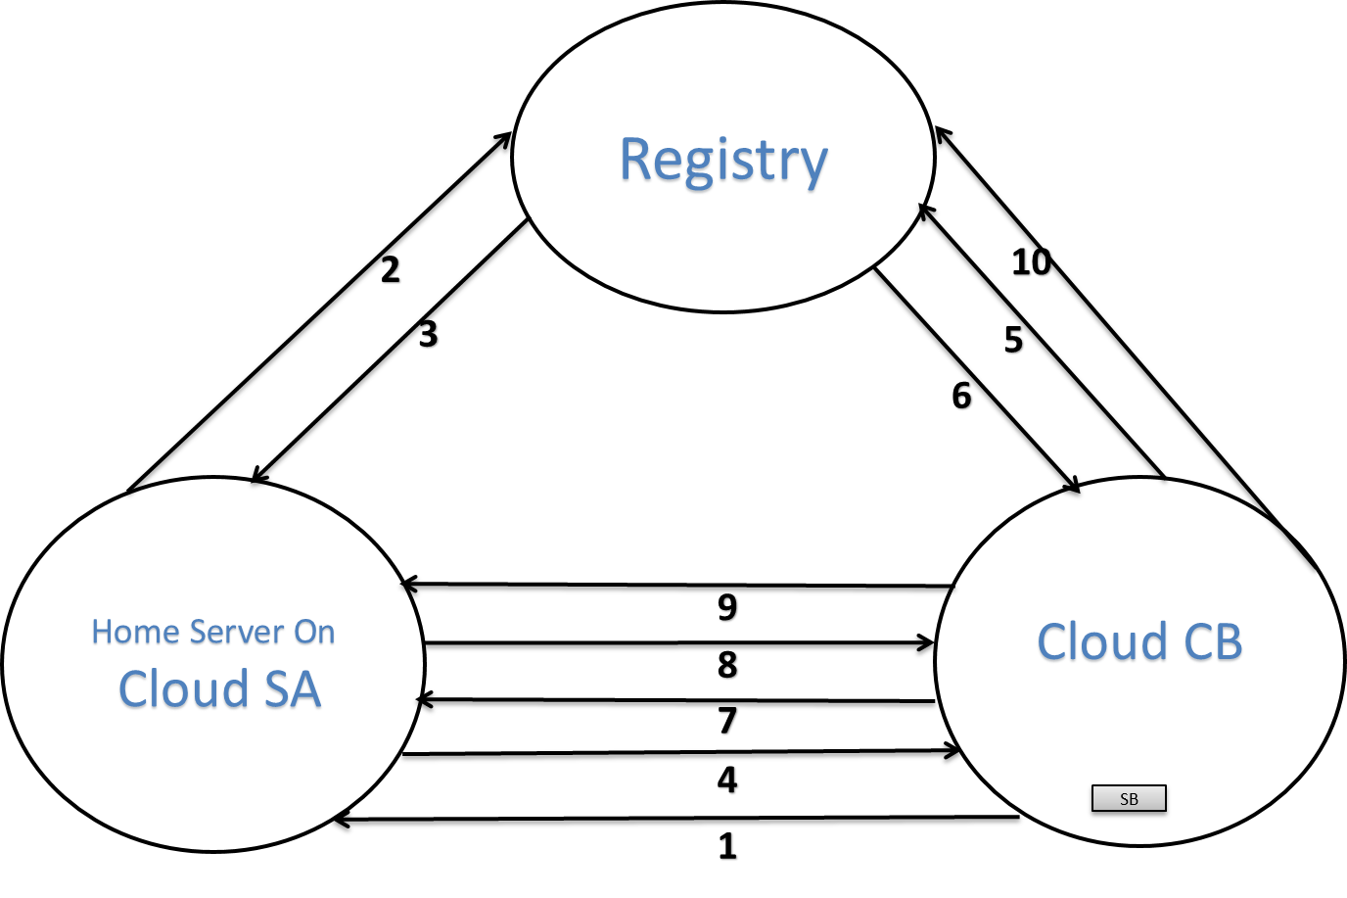

Fig.1: First Attempt Migration between SA to CB

Evaluation of the First Attempt:
There are important observations to be made with this protocol. Firstly, nonces are used to protect this session between server SA and Cloud CB to which the server wants to migrate. This is done using an extended approach based on the Needham Schroeder protocol. In step 4, the server uses NA as part of the transfer request, In step 7, Cloud B replies to the server using NA and NB as part of the transfer response. In step 8, server authorizes the transfer of the service to Cloud B using NB.

AVISPA Results
In our first attempt, AVISPA was used to analyse the protocol specified in the previous section. AVISPA provides automated validation of Internet security protocols and applications. Here, we represent the formal specification and verification is carried out using the role-based language, HLPSL and AVISPA model checker which automates the model checking of the protocol and uses the parameters necessary for the formal verification of RASP.
The first step was to validate the specification using the OFMC back-end tool of AVISPA, and the second step was to use the ATSE back-end. In our protocol, AVISPA Outputs SAFE from OFMC Fig.2 and ATSE Fig.3. Now, both of the protocol shows SAFE [4] so the expected result is accomplished.
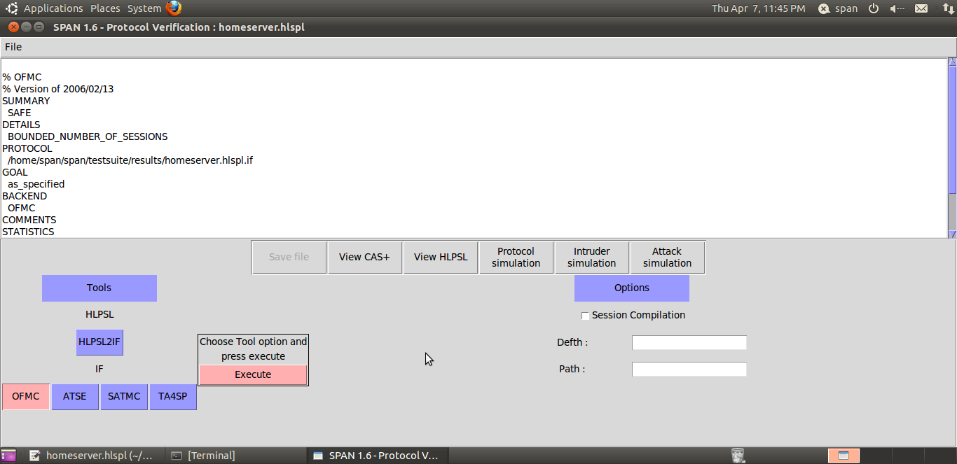
Fig.2: OFMC: Cloud SA to Cloud CB
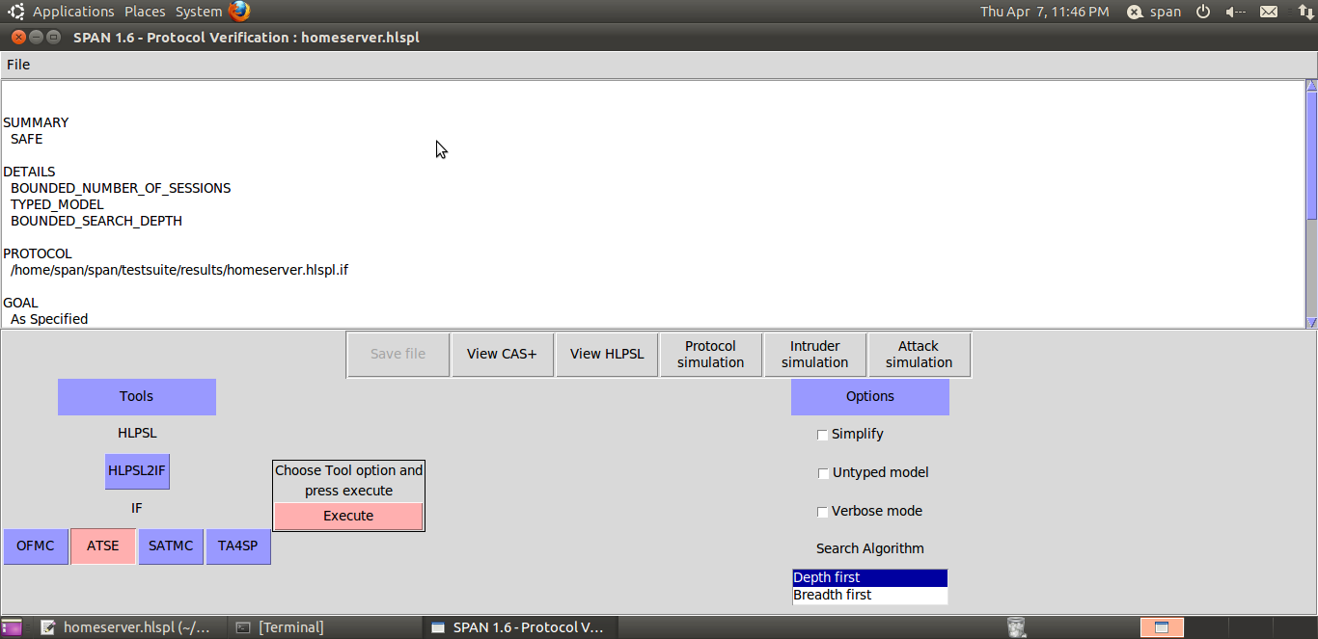
Fig.3: ATSE: Cloud SA to Cloud CB

Using the AVISPA tool, we are able to show that the protocol specified is safe against imposter attacks in normal operation. However, in order to create a complete security framework for Cloud Systems[6], we also need to look at verification of the cryptographic protocols. ProVerif is used for automatically analyzing the security of cryptographic protocols. In our second attempt, we used the ProVerif tool to fully verify the interaction between this secure service migration including the security properties such as the services, nonces, private keys, session keys, signatures, encryption and decryption mechanisms. Compare to AVISPA, ProVerif is a more expressive tool. Furthermore, AVISPA is sufficient for abstract protocols but ProVerif may help to model more of the Cloud infrastructure into the protocol thus allowing more expressive properties to be detailed and proved. Hence, ProVerif allows us to better define what is being attacked and hence what needs to be protected. ProVerif also features efficient automatic reasoning tools and is therefore potentially able to verify specific properties such as Cloud resources.

Second Attempt
In our second attempt, all these stages of the proposed protocol remain the same but implemented in a different way and tested by ProVerif [5]. ProVerif is an extension of Pi-calculus with cryptography. It follows Dolev-Yao models of cryptographic operation. ProVerif is capable of proving reachability properties, correspondence assertions and observational equivalence. It has wide varieties of protocol structures (event and the queries, private channels, rewrite rules, etc.) and modelling primitives used by cryptographic protocols (encryption, decryption, digital signatures, etc.). ProVerif’s internal abstraction has queries to verify the security properties and attempt to prove that a state in which the security properties are known to the attacker or not. If the queries are resulted as “True”, then the security property is not derived by the attacker. Additionally, it verifies the properties of the security protocol to prove secrecy (strong/weak), authentication and observational equivalence for an unbounded number of sessions using unbounded message space.

General Notations:
This Table2 represents Algorithm 2.
Notation | Explanation
CA | Cloud A
CB | Cloud B
R | Registry®
SA | Server SA on Cloud A
SB | New service on Cloud B
Ksc | Symmetric session key  between SA and CB
pkC/skC | Public / Private key pairs of Cloud B
pkS/skS | Public / Private key pairs of server SA
pkR/skR | Public/Private key pairs of Registry
Ns | Nonce of Cloud SA
Nc | Nonce of Cloud CB
Advc | Advertisements
ResSA | Requested Resources of SA
ResCB | Resources of CB
M_Reqc | Request for migration
M_Trfs | Transfer of migration
M_Ackc | Acknowledgement of migration
sign | Signature/signed by the Registry
aenc | Asymmetric Encryption
enc | Symmetric Encryption

Table 2. General Notations

Algorithm 2: Resource Allocation Security Protocol for Migration between server on Cloud A to Cloud B
As we stated earlier, the Algorithm 1 and Algorithm 2 remains the same but in Stage 3, we used a secure session key (Ksc) which is the symmetric key used for sessions between server SA and Cloud CB. In addition the same key will be used for encryption and decryption. Server SA generates the session key (Ksc), to start the migration request (M_Reqc). By using the session key (Ksc), Cloud CB begins the transfer (M_Trfs) and signals server SA when the transfer is completed (M_Ackc).
In this second attempt, Stage 1 corresponds to step1 of the protocol; Stage 2 corresponds to steps 2-7; Stage 3 corresponds to 8-11, and finally, Stage 4 corresponds to step 12. The RASP protocol is followed in exactly the same way an outlined below and Fig. 4 shows the steps for Cloud to Cloud migration of services.
Stage 1:
  - CB→SA : Advc (CB, ResCB)

Stage 2:
  - SA→R : (SA, CB, ResCB)pkS
  - R→SA : sign((CB, pkC, ResCB), pkS)
  - SA→CB : aenc ((Ns, SA , ResSA), pkC)
  - CB→R : (CB, SA , ResSA)pkR
  - R→CB : sign((SA, pkS , ResSA), pkC)
  - CB→SA : aenc((Ns, Nc, CB), pkS)
Stage 3:
  - SA→CB : aenc((Nc, Ksc), pkC)
  - CB→SA : enc ((M_Reqc, SA), Ksc)
  - SA→CB : enc ((M_Trfs, ResSA), Ksc)
  - CB→SA : enc ((M_Ackc), Ksc)
Stage 4:
  - SB→R : aenc((SB, CB), pkR)

The full explanation of this RASP protocol is given below:
- Step 1: Server SA receives advertisements from Cloud B advertising Cloud’s B resources with its identity CB.
- Step2: Server SA checks the validity of Cloud CB with the Registry.
- Step3: The Registry® authenticates server SA.
- Step 4: Server SA sends a migration request to Cloud CB.
- Step 5: Cloud CB sends a request to the Registry to make sure that server SA, is a valid requested resources (services).
- Step 6: The Registry® replies back to Cloud CB.
- Step 7: Cloud CB sends migration response back to server SA.
- Step 8: Server SA generates the session key (Ksc) to start the migration request.
- Step 9: Cloud CB sends the migration initialization request.
- Step 10: Server SA does the migration transfer.
- Step 11: Cloud CB sends an acknowledgement to server SA.
- Step 12: Service on Cloud B (SB) updates its new location to The Registry®.

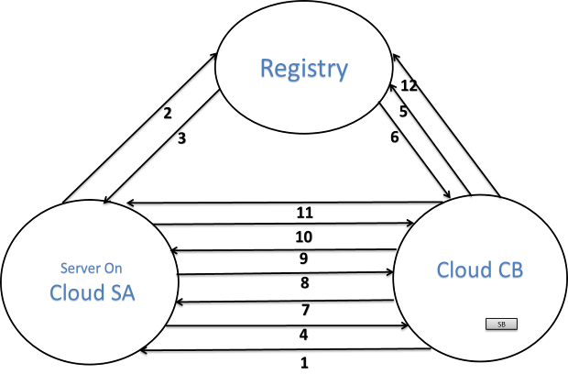

Fig.4: Second Attempt Migration between SA to CB

Stages in detail:
- Stage1
Cloud CB advertise (Advc) its resources which are picked up by server on Cloud A (SA). It is essential for service on the Cloud to trust their terminals before it migrates the services. Clouds SA and CB, they don’t know anything about each other/no prior communication between SA and CB. In the first step, the server SA receives an advertisements from Cloud B advertising Cloud’s B resources (ResCB) with its identity CB.
- CB→SA: Advc (CB, ResCB)

- Stage 2
Both entities, server SA and Cloud B, must be authenticated to each other. Firstly, on receiving an advertisement from CB, SA checks the validity of Cloud B with the Registry®. So it sends its identity SA, Cloud B’s identity CB and resources of Cloud B (ResCB) by using public key of Registry®.
The Registry® will be able to verify the validity of any Cloud resources. The Registry® replies back to server SA, saying that Cloud CB is a valid Cloud and encrypts the response with the public key(pkS) of SA and signs the response with its private key. Therefore, digital signature ensures that Registry® is the originator of the message.
SA generates and sends a fresh nonce (Ns), its identity SA, requested resources (ResSA) and encrypts it using its public key (pkC). Nonces are used to protect this session between the server SA and the Cloud B to which the server wants to migrate.
When CB receives this message, it decrypts it using its private key (skC). Cloud CB verifies the request made by SA by forwarding the requested resources of SA (ResSA), SA’s identity and CB’s identity to the Registry by using public key (pkR) of Registry®.
The Registry® replies back to Cloud CB, it validates server SA and encrypts the response with Cloud CB’s public key and signs it with its private key.
- SA→R : (SA, CB, ResCB) pkR
- R→SA : sign ((CB, pkC, ResCB), pkS)
- SA→CB : aenc ((Ns, SA , ResSA), pkC)
- CB→R : (CB, SA , ResSA) pkR
- R→CB : sign ((SA, pkS , ResSA), pkC)
- CB→SA : aenc((Ns, Nc, CB), pkS)

- Stage 3
In Stage 3, server SA generates a fresh symmetric session key (_{Ksc}), pairs it with nonce of CB (Nc), encrypts by using Cloud B’s public key (pkC) and sends to CB.
Cloud B initiates the migration request (_{M_Reqc}), pairs it with server SA, and encrypts it using generated symmetric session key (_{Ksc}).
Once the migration request (_{M_Reqc}) from CB to SA is received, SA is able to decrypt it by using its private key (_{skS}) and start the migration transfer (_{M_Trfs}) with requested resource (_{ResSA}) by using symmetrical session key (_{Ksc}). Once the migration transfer (_{M_Trfs}) is completed, CB sends an acknowledgement (_{M_Ackc}), to server SA by using Ksc.

- SA→CB : aenc ((Nc, Ksc), pkC)
- CB→SA : enc ((M_Reqc, SA), Ksc)
- SA→CB : enc ((M_Trfs, ResSA), Ksc)
- CB→SA : enc ((M_Ackc), Ksc)

- Stage 4
In Stage 4, the service (SB) updates its new location to the Registry® and hence SA->SB.
- SB→R : aenc ((SB, CB), pkR)

Evaluation of the Second Attempt
In our second attempt, by using symmetric session key (Ksc), the requested service is transferred to the new location CB. As we mentioned in the first attempt, nonces are used to protect this session between server SA and Cloud CB. However, in the second attempts, the symmetrical session key is used to do the actual transfer and hence it’s regarded as more secure mechanism than using nonces.

ProVerif Results
The results show that RASP can preserve the secrecy, authentication and key exchange of the service migration mechanism. We verified Stage 2 and Stage 3 using ProVerif tool and presented the output of the program which is given in Fig.5 below. The security properties were specified in the input language to check whether it is derivable by the attacker or not.
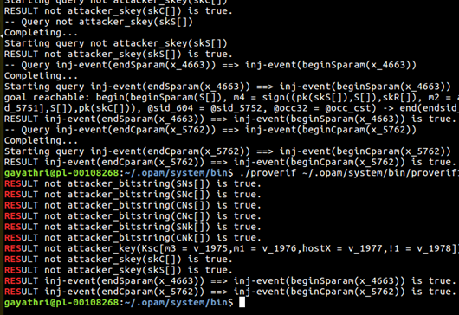
Fig. 5: Second Attempt Migration between SA to CB
(Results:gayathri@pl0108268:~/.opam/system/bin$./ProVerif/.opam/system/bin/proverif1.98pl1/docs/Nee/ CB toSA_SecuirtyProtocol.pv | grep "RES".
- Nonces are secured and not derived by the attacker.
- RESULT not attacker_bitstring (SNs []) is true.
- RESULT not attacker_bitstring (SNc []) is true.
- RESULT not attacker_bitstring (CNs []) is true.
- RESULT not attacker_bitstring (CNc []) is true.
- The session key is not derived by the attacker.
- RESULT not attacker_key (Ksc [m3 = v_1975, m1 = v_1976, hostX = v_1977! 1 = v_1978]) is true.
- RESULT not attacker_bitstring (SNk []) is true.
- RESULT not attacker_bitstring (CNk []) is true.
- Private keys of server on Cloud (SA) and Cloud B (CB) is not derived by the attacker.
- RESULT not attacker_skey (skC []) is true.
- RESULT not attacker_skey (skS []) is true.
- Authentication SA to CB and CB to SA is true.
- RESULT inj-event (endSparam (x_4663)) ==> inj-event (beginSparam (x_4663)) is true.
- RESULT inj-event (endCparam (x_5762)) ==> inj-event (beginCparam (x_5762)) is true.
gayathri@pl-00108268:~/.opam/system/bin$))

Application to Vehicular Test Bed
The rapid growth in the number of vehicles on the roads has created a plethora of challenges for road traffic management authorities such as traffic congestion, increasing number of accidents, air pollution, etc. Over the last decade, significant research efforts from both the automotive industry and academia have been undertaken to accelerate the deployment of the Wireless Access in Vehicular Environments (WAVE) standard based on a Dedicated Short Range Communication (DSRC) among moving vehicles (Vehicle-to-Vehicle, V2V) [8] and roadside infrastructure (Vehicle-to-Infrastructure, V2I). This network is called a VANET network and is characterized by high node speed, rapidly changing topologies, and short connection lifetimes. VANETs are realized by the deployment of Roadside Units (RSUs) located along the transport infrastructure and Onboard Units (OBUs) in the vehicles or worn by pedestrians or cyclists. Based on the protocol presented, which was verified using Proverif, VANET systems would be the best option. Hence, the protocol will be tested on a VANET test bed developed by Middlesex University on the Hendon Campus.

CONCLUSIONS and FUTURE WORK
This paper has presented a new Resource Allocation Security Protocol (RASP) for server migration between commercial Cloud environments. In our first attempt, using AVISPA tool, we showed that the protocol is safe under normal operation; the present protocol critically prevents impersonation attacks either by rogue Cloud infrastructure hoping to sneer valid services or by malicious servers wanting to inflict damage on Cloud Infrastructure. In our second attempt, using ProVerif, we showed that the proposed protocol succeeds in three significant security properties namely: secrecy, authentication of SA to CB and CB to SA, and secure symmetric key exchange.
More work is being done to analyses intruder attacks to show that the proposed protocol is secure against the active and passive attacks. We are exploring how this protocol be enhanced to prevent intruder and man-in-the-middle attacks.

References

- G Mapp, F Shaikh, J Crowcroft, D Cottingham, and J Baliosian. 2007. Y-Comm: A Global Architecture for Heterogeneous Networking (Invited Paper). In 3rd Annual International Wireless Internet Conference (WICON).
- Sardis M, Mapp G. E, Loo J, Aiash M, and Vinel A. 2013. On the Investigation of Cloud-based Mobile Media Environments with Service-Populating and QoSaware Mechanisms. IEEE Transactions on Multimedia (January 2013).
- Paranthaman V.V. et al. (2017) Building a Prototype VANET Testbed to Explore Communication Dynamics in Highly Mobile Environments. In: Guo S., Wei G., Xiang Y., Lin X., Lorenz P. (eds) Testbeds and Research Infrastructures for the Development of Networks and Communities. TridentCom 2016. Lecture Notes of the Institute for Computer Sciences, Social Informatics and Telecommunications Engineering, vol 177. Springer, Cham
- Gayathri Karthick, Glenford Mapp, Florian Kammueller, and Mahdi Aiash. 2017. Exploring a Security Protocol for Secure Service Migration in Commercial Cloud Environments. In Proceedings of International Conference on Internet of Things, Data and Cloud Computing, Cambridge, United Kingdom, March 2017 (ICC’17), 7 pages.
- Florian Kammüller, Christian W. Probst, "Modeling and Verification of Insider Threats Using Logical Analysis", Systems Journal IEEE, vol. 11, no. 2, pp. 534-545, 2017.
- M Aiash, G Mapp, A Lasebae, R Phan, and J Loo. 2013. Integrating Mobility,Quality-of-Service and Security in Future Mobile Networks. Electrical Engineering and Intelligent Systems: Lecture Notes in Electical Engineering 130 (2013), 195–206.
- Mapp G.E Aiash M and Gemikonakli O. 2014. Secure Live Migration: Issues and Solutions. In Proceedings of the Conference on Advanced Information Networking and Applications, AINA 2014, Victoria, Canada.
- A. Ghosh, V. V. Paranthaman, G. Mapp, O. Gemikonakli and J. Loo, "Enabling seamless V2I communications: toward developing cooperative automotive applications in VANET systems," in IEEE Communications Magazine, vol. 53, no. 12, pp. 80-86, Dec. 2015.
- F Sardis, G.E Mapp, J Loo, and M Aiash. 2014. Dynamic edge-caching for mobile users: Minimising inter-as tra_c by moving Cloud services and vms. In Proceedings of the Conference on Advanced Information Networking and Applications, AINA 2014, Victoria, Canada.

